**Preschool Supply List**

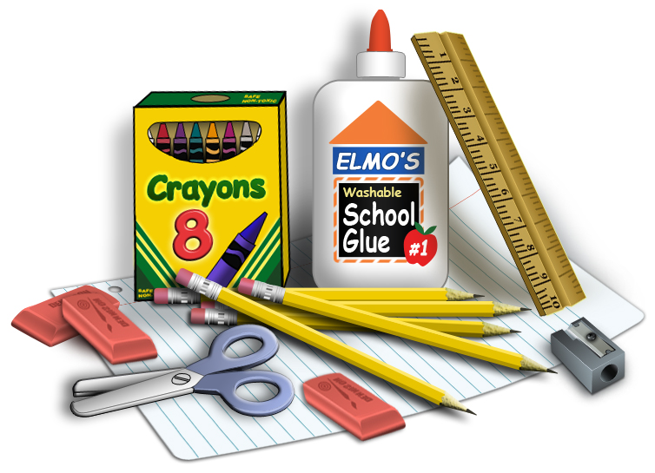

**Class Fee: $40 Class Fee** (cash or check made out to Spanish Springs Elementary) – money will be used to purchase all individual classroom supplies such as glue, tissue, scissors, crayons, markers, art/holiday projects, ink, expo markers, folders, etc.

* **3-ring binder -** Hard cover, one-inch width, with a pocket on the inside. If the binder starts to fall apart, we will ask that you replace the binder.
* **Family pictures –** These pictures will be cut and glued into a scrapbook that will remain at school for the school year and is part of our first unit.
* **Backpack –** Please ensure backpacks are big enough to fit ALL items coming to school. ALL items must remain in the backpack and the child is required to carry his/her own backpack.
* **Diapers and wipes -** If not potty trained, please plan with teacher regarding these items. Parents are required to provide diapers and wipes.
* **Change of clothes –** This isfor emergency purposes. Please place these items in a large zip-lock bag with the child’s name on it. This zip-lock bag will be left in the classroom for the school year so consider seasonal changes.
* **Lunch –** Please send your child a cold lunch each day they are in class. Cafeteria lunches are free this school year. If your child is having a hot lunch, please communicate this daily with the teacher.
* **Reusable water bottle –** Labeled with name. NO disposable, plastic twist top water bottles.
* **Contribution for Daily Snack –** Healthy snacks please! Examples: granola bars, goldfish, graham crackers, cheese sticks, Gogurts, etc. NO NUTS OR JUICE.
* **Clorox wipes, Tissue Box, and Glue Sticks**
* **Optional –** 6-inch or smaller stuffed animal for rest time – NO blankets, pillows, toys, etc. Any extra art supplies you have, such as buttons, yarn, Q-tips, etc.